**MARTIN L King & Coretta King**

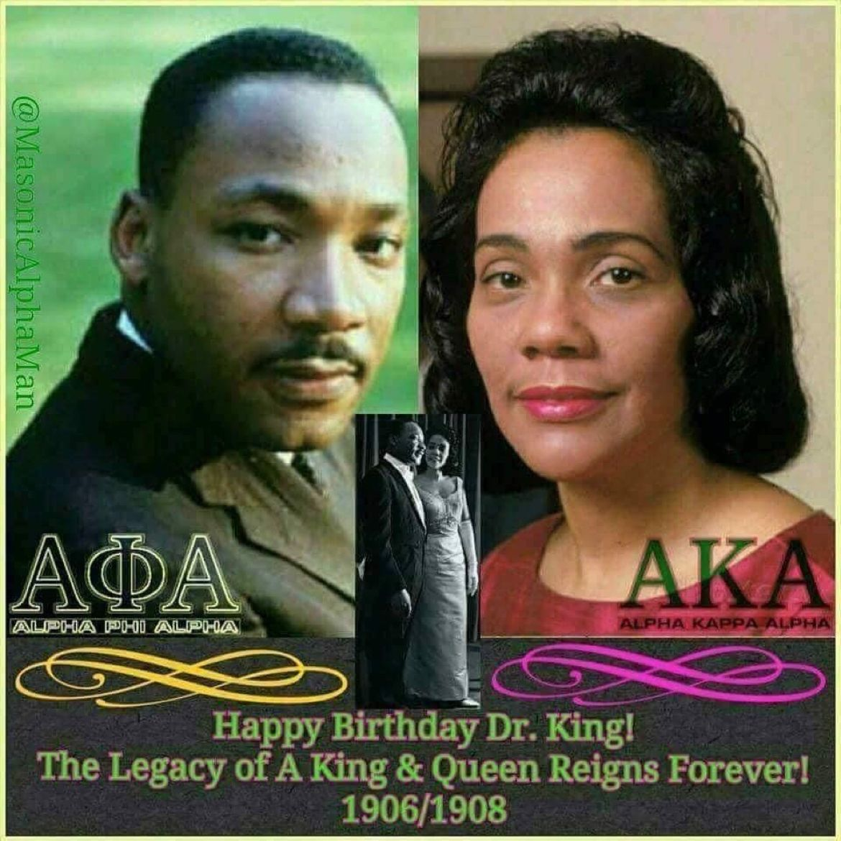

[Janice Underwood, PhD(She/Her) • FollowingGovernment-wide Chief Diversity Officer, DEIAvenger](https://www.linkedin.com/in/janiceunderwood?miniProfileUrn=urn%3Ali%3Afs_miniProfile%3AACoAACSghTYB5ElyvsOzGSsX2syL_ycwsf7Vibw" \t "_self)

[2d • Edited • 2 days ago](https://www.linkedin.com/in/janiceunderwood?miniProfileUrn=urn%3Ali%3Afs_miniProfile%3AACoAACSghTYB5ElyvsOzGSsX2syL_ycwsf7Vibw" \t "_self)

The Urgency of Now!  
  
As we reflect collectively on Dr. Martin Luther King today, we must remember that together, he and Coretta Scott King fought for equity as a vehicle to reach opportunity and equality. In fact, let’s too remember the many women who fought alongside the men of the civil rights era. “From chaos to community” runs right through [#EQUITY](https://www.linkedin.com/feed/hashtag/?keywords=equity&highlightedUpdateUrns=urn%3Ali%3Aactivity%3A7020814214176931840)! We must also all be sure to remind those who love to misquote [#MLK](https://www.linkedin.com/feed/hashtag/?keywords=mlk&highlightedUpdateUrns=urn%3Ali%3Aactivity%3A7020814214176931840) or remove him from our American history standards:  
1. Misquoting or the cultural misappropriation of Dr King’s memory is a contemporary attempt at revising history to make certain folks feel more at ease with Dr. King’s memory;  
2. The same folks who love to misquote [#MLK](https://www.linkedin.com/feed/hashtag/?keywords=mlk&highlightedUpdateUrns=urn%3Ali%3Aactivity%3A7020814214176931840) today may be the same folks who would hate him if he were still alive or would have hated him in the 1960’s. In fact, in 1968, Dr. Martin Luther King Jr.'s disapproval rate was nearly 75% and 50% of White Americans reported that MLK was hurting the civil rights movement; and  
3. Dr. King said that injustice anywhere is a threat to justice everywhere which was his way to criticize people in a bipartisan way because silence by anyone was unacceptable but esp warned us about folks who claimed they were liberal about civil rights but too scared to act.  
  
Take a moment and watch this incredible sermon in his own words…  
<https://lnkd.in/g4FKGxZg>